## PROJECT REPORT OF INSURANCE MANAGEMENT SYSTEM

**ABSTRACT**

**Insurance management system project** is implemented in python platform using Django as backend application. Main aim of this project is to develop a online application for insurance company to atomize work procedure, using this system agents and policy holders can know details about present policies, schemes, policy specifications, terms and conditions on policy, policy registration by the customers. Agents commission is based upon customer policy registration and target agent achieves for every month or year. This system maintains information of branch managers who can deal with agents and customers.

**CHAPTER1**

**INTRODUCTION**

The capstone project, “Insurance Management System in Django” is designed to streamline the day-to-day operations and transactions of insurance agencies. The software will introduce marketing automation, customer relationship, and records management of the business.

Conventionally, insurance agencies operate, market, and transact with clients mostly using manual approaches and with only a little technological intervention. Usually, insurance agents and clients personally do transactions where the agent explains to the clients the coverage of the insurance along with the payment required. Insurance agencies manage records of policies, policyholders, and other transactions of the business manually with only a little use of technology. This pre-existing method is prone to difficulties due to physical barriers and time constraints.

## 1.1 ****Proposed Solution****

The development of the Insurance Management System in Django serves as a solution to resolve issues and difficulties in insurance management. The proposed system is designed to streamline the day-to-day operations and transactions of insurance agencies. The insurance agent can electronically present insurance policies offered by the agency as well as attend to the inquiries of the clients using the software. Clients also can apply for insurance policies online and the agency can either approve or reject their applications. Overall, the system will make insurance management easy, fast, efficient, accurate, and reliable.

## 1.2 ****Objectives of the Study****

**General Objective –** The main goal of the researchers is to design, develop and implement an Insurance Management System that will support the day-to-day operations of insurance agencies and automate management processes.

Specifically, the researchers aim the following objectives:

1. To develop a system that will streamline the operation and transactions of insurance agencies.
2. To introduce a platform that will automate insurance agency’s marketing.
3. To simplify and ease up insurance agency’s data management.
4. To introduce electronic encoding of policy form and customer data.
5. To reduce manual workloads of insurance agencies.
6. To evaluate the system in terms of user acceptability, effectiveness, quality, productivity, and reliability.

## ****Scope of the Study****

This study mainly focuses on the implementation of an Insurance Management System in Insurance agencies. The researchers will design software that will digitally transition the daily operations and transactions of the insurance agency. The system will be designed as a platform for insurance management that also permits transactions between the agencies and clients. Insurance agencies and clients will participate as respondents to the study.

## ****Significance of the Study****

The success of the project is highly beneficial for the following:

**Insurance Agencies.**The success of the project will directly benefit insurance agencies. The success of the software will introduce them to a more advantageous platform that will increase their operational efficiency as well as customer relationship.

**Clients.**Those who wanted to inquire about insurance and be legitimate policyholders can easily and conveniently browse for insurance policies that an insurance agency offered. The software will help them have easy, fast, and efficient transactions with insurance agencies.

**Researchers.**The researcher’s experience in conducting the study will further harness their skills, knowledge, and potential as programmers and developers.

**Future Researchers. T**hey can use the study as their reference in their future pursuit of the same study.

## ****Development Tools****

The capstone project “Insurance Management System in Django” is a system that allows insurance agencies to electronically manage the agencies’ insurance policies and records of policyholders and transactions. The software is an online platform to support the day-to-day operations and transactions of insurance agencies.

This article will provide you with an idea on what are the forms to be included in an Insurance Management System in Django. PHP and Bootstrap were used to develop the said template.

**CHAPTER 2**

**2. REQUIREMENTS**

| About Project | Project Details |
| --- | --- |
| Project Name | Railway Reservation System Project in Django |
| Python version (Recommended) | 3.8 Version |
| Programming Language Used | Python Django Language |
| Developer Name | itsourcecode.com |
| IDE Tool (Recommended) | Sublime, Visual Studio, PyCharm |
| Project Type | Web Application |
| Database Used | SQLite |

**Chapter 3**

## Django framework

Django is an open source web application frame work written in Python. The primary goal of Django is to make the development of complex, data-based websites easier. Thus Django emphasizes the reusability and pluggability of components to ensure rapid developments. Django consists of three major parts: model, view and template[4].

### Model

Model[4] is a single, definitive data source which contains the essential field and behavior of the data. Usually one model is one table in the database. Each attribute in the model represents a field of a table in the database. Django provides a set of automatically-generated database application programming interfaces (APIs) for the convenience of users.

### View

View[4] is short form of view file. It is a file containing Python function which takes web requests and returns web responses. A response can be HTML content or XML documents or a “404 error” and so on. The logic inside the view function can be arbitrary as long as it returns the desired response. To link the view function with a particular URL we need to use a structure called URLconf which maps URLs to view fucntions.

4

### Template

Django’s template[4] is a simple text file which can generate a text-based format like HTML and XML. The template contains variables and tags. Variables will be replaced by the result when the template is evaluated. Tags control the logic of the template. We also can modify the variables by using filters. For example, a lowercase filter can convert the variable from uppercase into lowercase.

## Python

## Python[2] is the language used to build the Django framework. It is a dynamic scripting language similar to Perl[5] and Ruby[6]. The principal author of Python is Guido van Rossum[7]. Python supports dynamic typing and has a garbage collector for automatic memory management. Another important feature of Python is dynamic name solution which binds the names of functions and variables

## ****Project Highlights****

Insurance Management System is a database-driven system that will automate the processes of recording and keeping orderly and accurate insurance processes and transactions.

The advantages of the Insurance Management System are the following:

1. Automated management- the system will enable the electronic management of insurance records.
2. Records Management – it is a database system that makes the records of insurances electronic, safe, accurate, reliable, and fast.
3. Report Generation – the system is capable of generating reports about the records in the insurance agency

## ****How the System Works****

This paper will discuss the forms, modules, and user interface of an Insurance Management System. We will discuss the features and how the system works.

**Homepage** – this page will is first displayed when the user accesses the system.

The image below is the design of the system’s homepage.

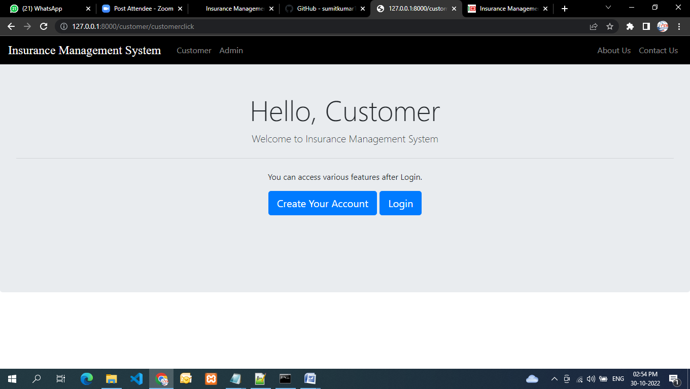

**Admin Dashboard** – this serves as the main page of the system’s administrator. Insurance-related records are displayed in the dashboard and are managed by the administrator.

The dashboard mainly displays the following information:

* Total Registered Users
* Listed Policies
* Listed Categories
* Total Applied Policy Holder
* Of Approved Policy Holder
* Of Disapproved Policy Holder
* Of Policy Holder Waiting for Approval

Shown below is the design of the administrator’s dashboard.

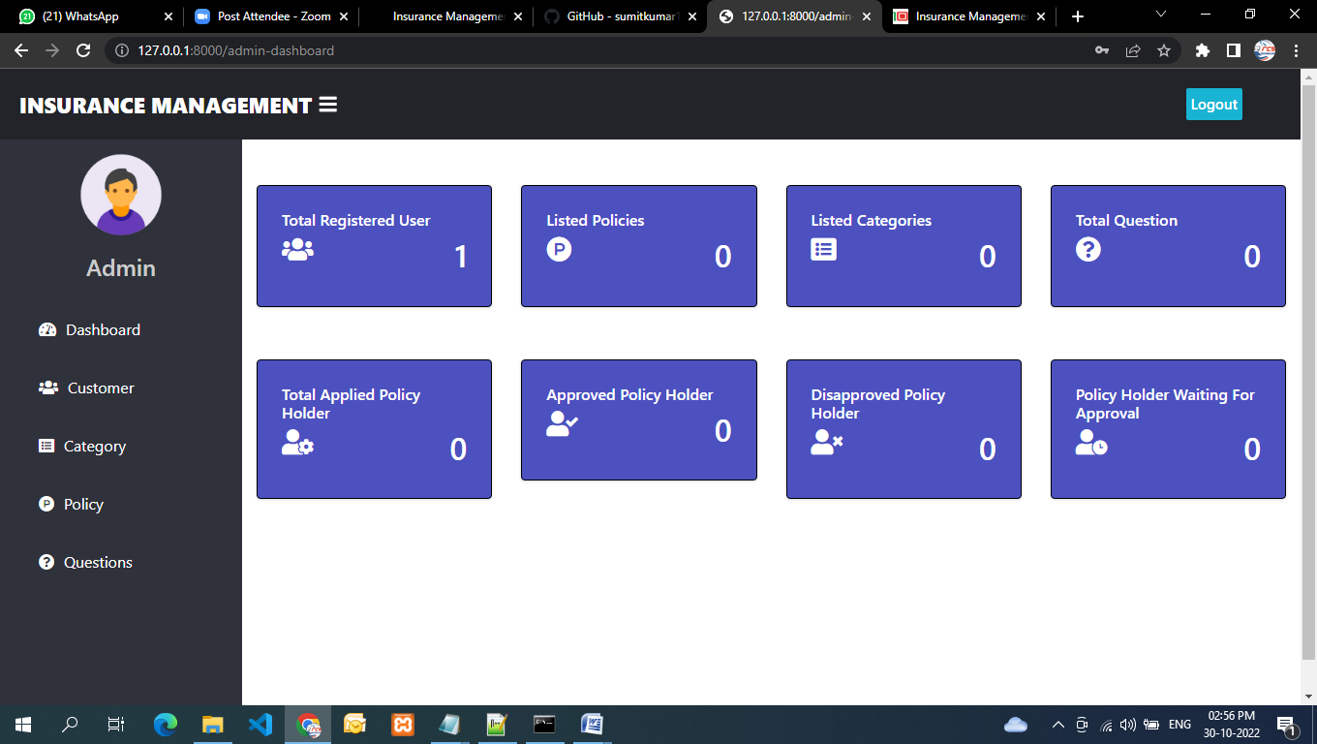

**Policy form** – this form will allow the admin to manage the listed insurance policies in the system. The admin can view, add, update or delete listed policies.

The following information is encoded and managed by the admin:

* Total Applied Policy Holder
* Approved Policy Holder
* Disapproved Policy Holder
* Policy Holder Waiting for Approval
* Action – (view, add, update, delete)

The image shown below is the design of the Policy form.

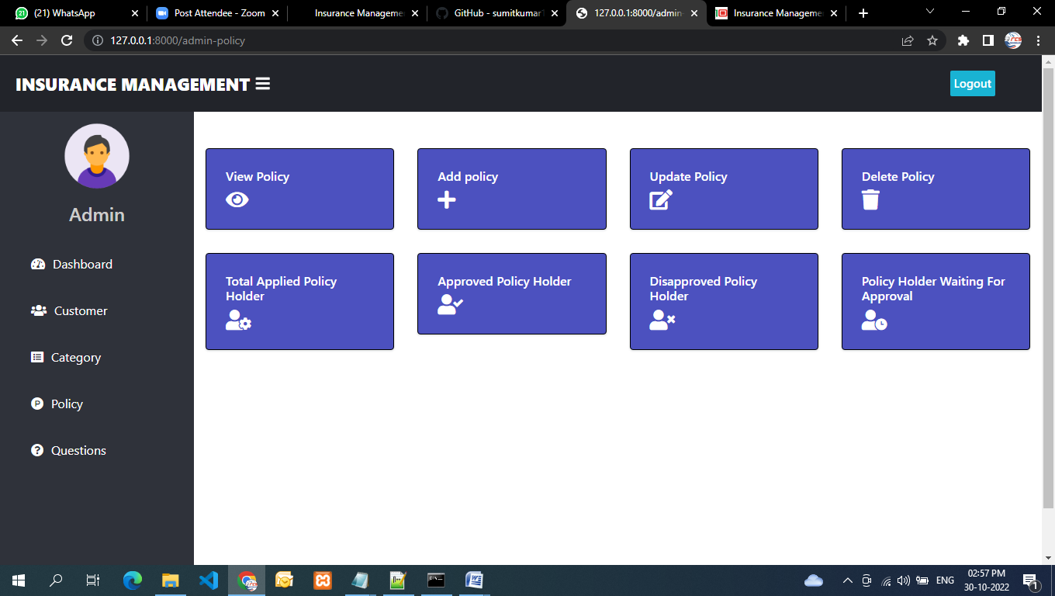

**Policy Record** – this form will require the admin to encode and manage the records of policies and policyholders.

The admin will encode the following information:

* Serial No.
* Policy Name
* Customer Name
* Applied Date
* Status – ( approved, rejected, pending)
* Action -(approve or reject)

Shown below is the policy record form design.

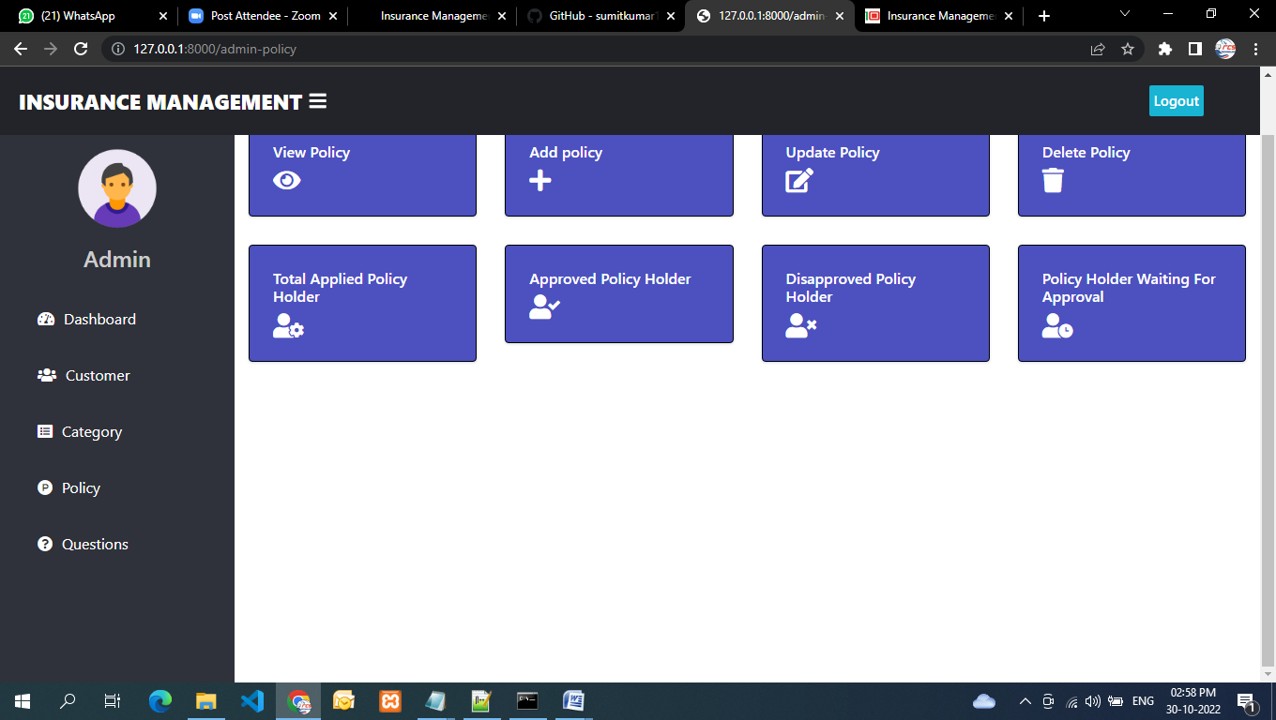

## ****Conclusion****

The tough competition in the insurance businesses market prompted insurance companies and agencies to advance their marketing strategy and management aspects. The researchers conducted the study to develop an Insurance Management System. The developed system was presented to its intended users for assessment. The result of the study showed that the developed system provides the needs and requirements of the respondents and intended users. The majority of the project’s respondents have seen the efficiency and reliability of the system in streamlining insurance management.

Thus, the researchers concluded that the developed system is an effective tool for insurance management. The system will ease up and simplify the operations and management processes of insurance agencies. The agency can automate recording and storing records of insurance policies, policyholders, and other insurance-related documents. The system will make insurance management easy, fast, efficient, accurate, and reliable.

## ****Recommendations****

The significant result of the study prompted the researchers to strongly recommend the implementation of the system. The system is highly recommended for its efficiency and reliability that can be rendered to the intended users. The system will improve the operations, services, and overall experience of insurance agency clients and policyholders. The developed system will significantly change the agent-policy holder transaction. The researchers highlight the importance of having enough knowledge on how to properly utilize and operate the system.

The researchers specifically recommend the following:

1. The researchers strongly suggest that the system should be used by insurance agencies to advance their business operations, transactions and improve their businesses efficiency.
2. The researchers suggest that insurance agency’s clients utilize the software to easily and conveniently apply for an insurance policy.
3. The implementation of the system will effectively transform insurance agent-clients transactions.